Technical Handing-Taking Over of Damchekha Irrigation Scheme

Chhukha Dzongkhag, 27 August 2026: The Technical Handing-Taking Over of the Damchekha Irrigation Scheme was carried out on 27 August 2026, following the successful completion of the irrigation project at Damchekha.
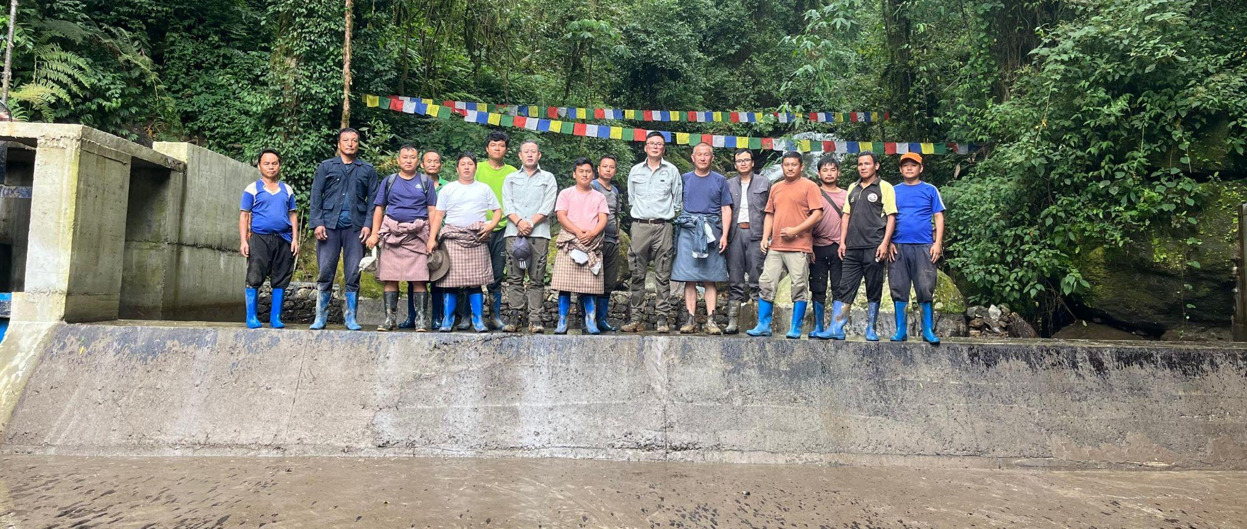
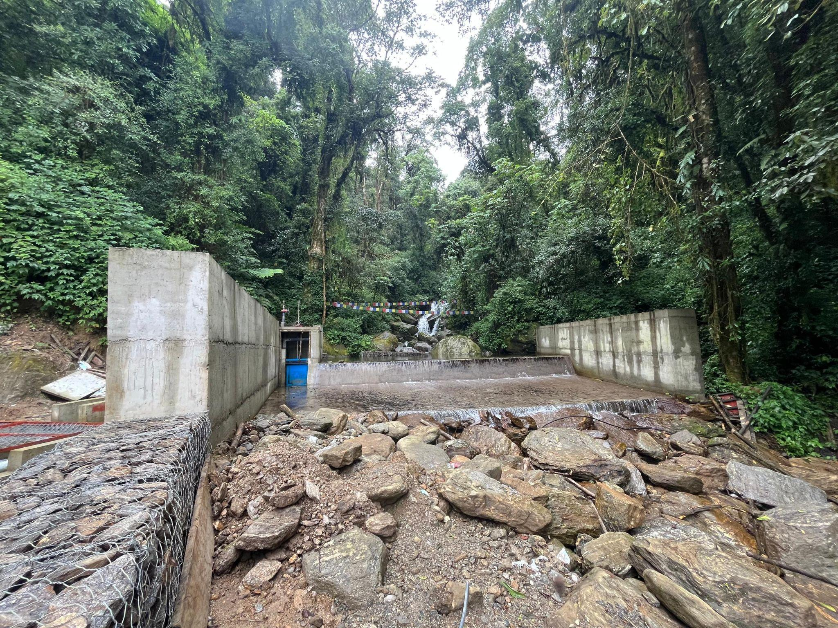
The irrigation scheme was constructed by M/s Karma & Chimmi Builders Pvt. Ltd., Thimphu, with a contract amount of Nu. 36,654,797.20. The project was funded by the Department of Agriculture (DoA), Ministry of Agriculture and Livestock (MoAL), with technical support from the Irrigation Division, Department of Infrastructure Development (DoID), Ministry of Infrastructure and Transport (MoIT), Thimphu.

The project commenced on 5 December 2025, with an initial scheduled completion date of 5 December 2026. However, the contractor successfully completed the construction works on 17 August 2026, well ahead of the scheduled completion date.

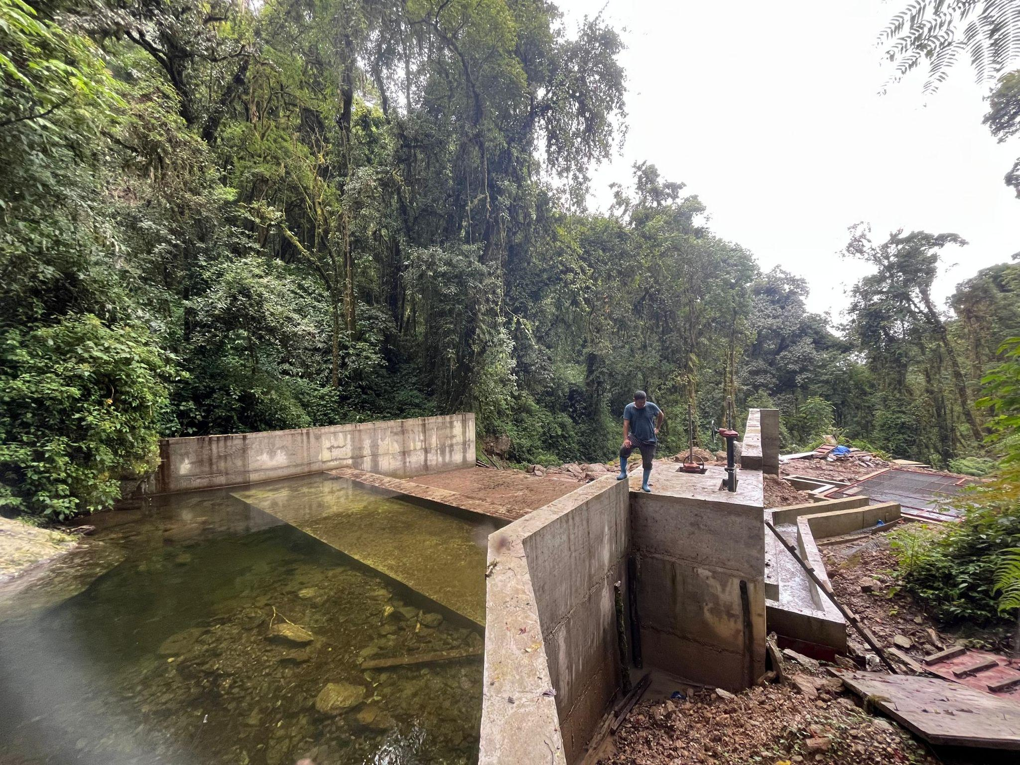
The irrigation scheme draws water from the Chuktilum water source, which is a permanent and reliable source of water. The completed irrigation system extends approximately 9 km and is expected to benefit 54 households, covering approximately 71 acres of wetland and providing irrigation support to more than 100 acres of dryland.

The scheme is expected to significantly enhance agricultural production and improve water availability for farming communities. In particular, farmers will be able to make productive use of the irrigation facilities beyond the paddy cultivation season by utilizing the available water for dryland irrigation and the cultivation of other crops during the off-season. This will provide opportunities for crop diversification, increased land utilization and improved farm productivity.

During the technical monitoring and inspection of the completed works, the construction quality and physical progress were found to be satisfactory. The technical team also reviewed the relevant records and sought feedback from the beneficiary farmers regarding the completed irrigation infrastructure.

As an additional measure to ensure the quality and proper functioning of the scheme, the technical team requested the contractor to remain at the project site for an additional one-week observation and rectification period. The contractor agreed to keep the necessary labour force at the site during this period and to undertake any rectification works immediately should any defects or issues be identified by the technical team or beneficiary farmers.
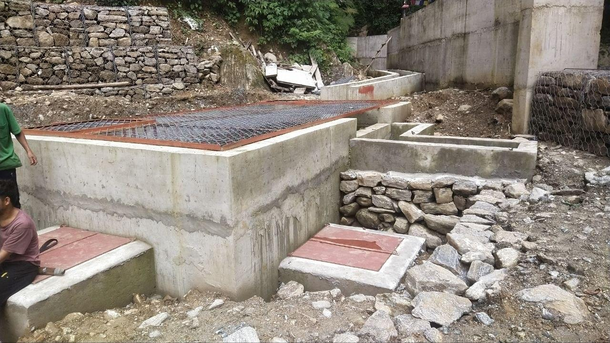
Although the project carries a one-year liability period, the additional one-week site presence was agreed upon to facilitate immediate identification and rectification of any minor defects following the handing-takeover.

The Technical Handing-Taking Over marks an important milestone in the development of irrigation infrastructure in the area and is expected to contribute towards enhanced agricultural production, improved utilization of dryland and wetland areas, and increased livelihood opportunities for the beneficiary farming households.
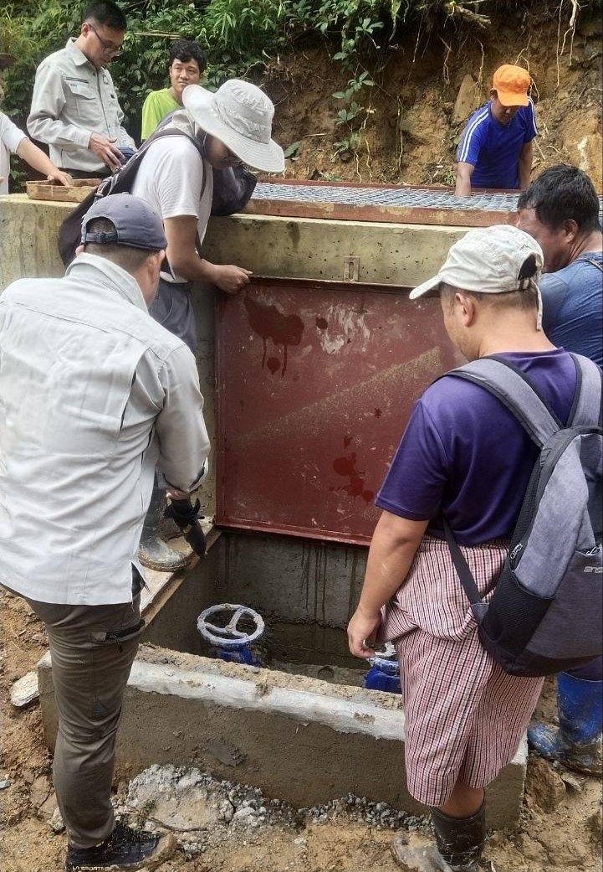
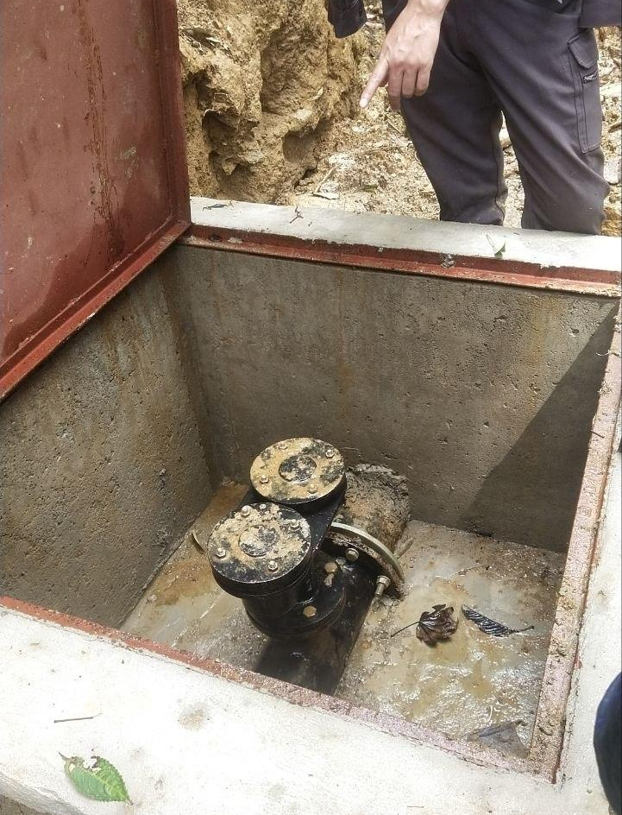
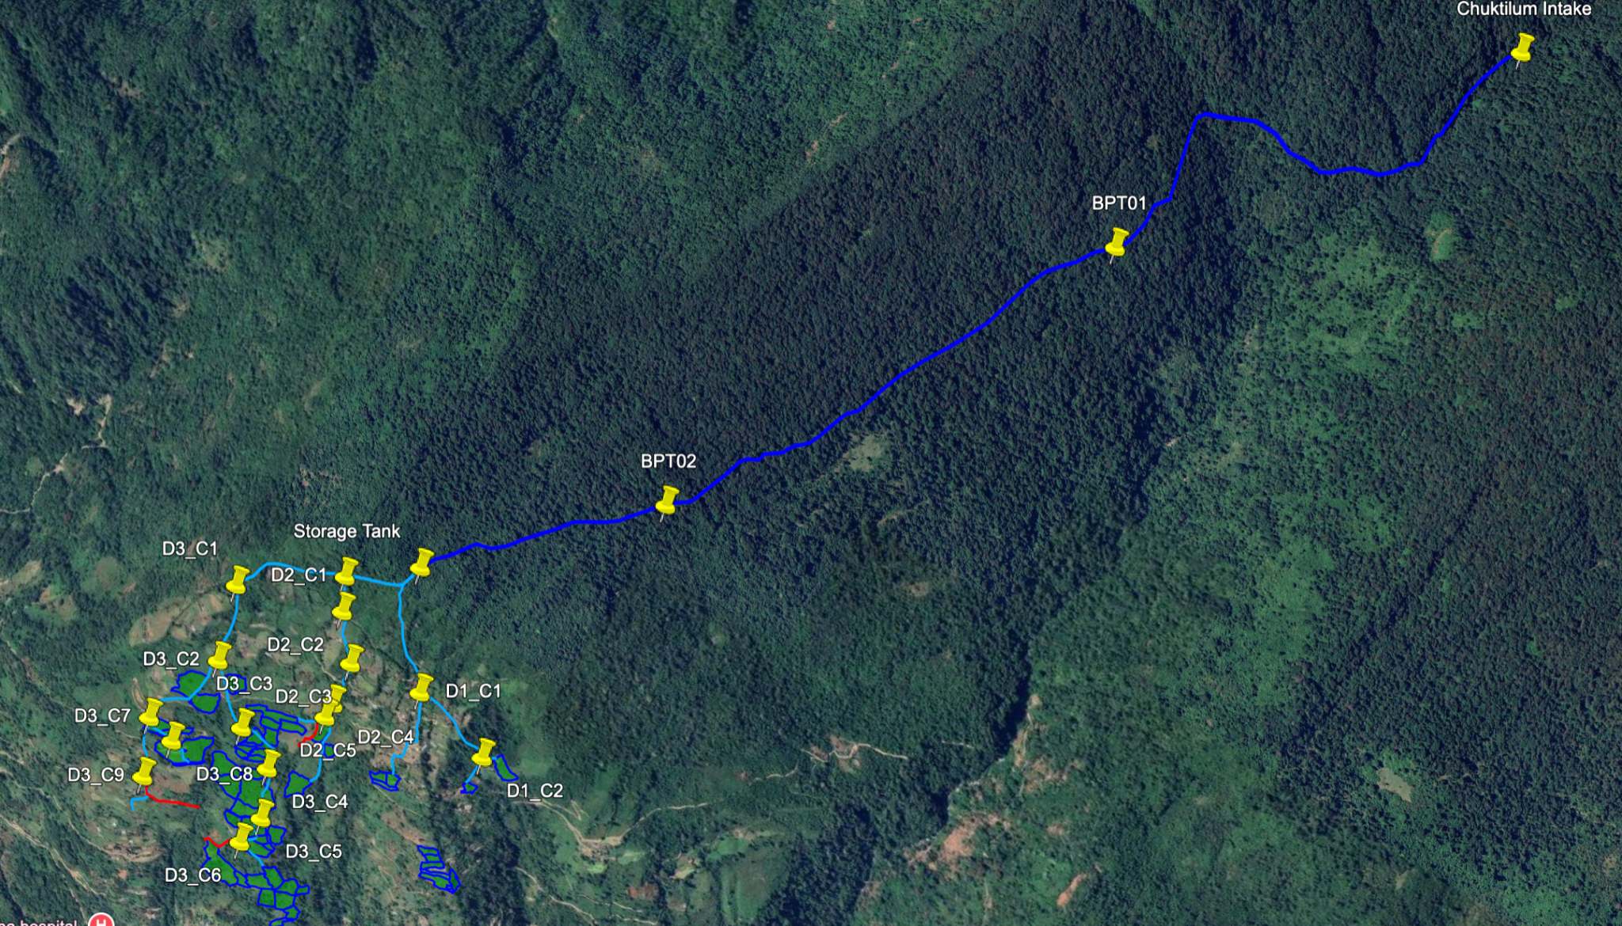
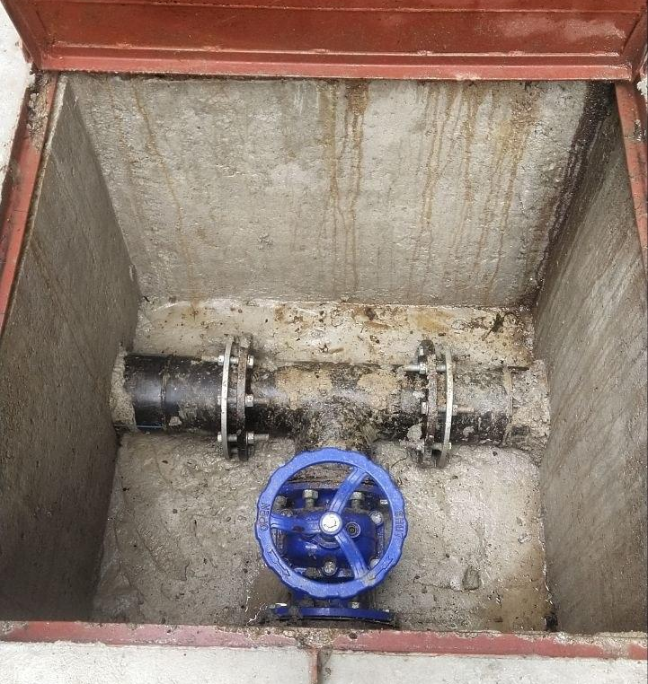
The Dzongkhag Administration appreciates the support of the Department of Agriculture, MoAL, the Irrigation Division, DoID, MoIT, the contractor, and the beneficiary farmers for their coordination and cooperation in successfully completing the project ahead of schedule.

